Vendor Performance & Inventory Optimization Dashboard
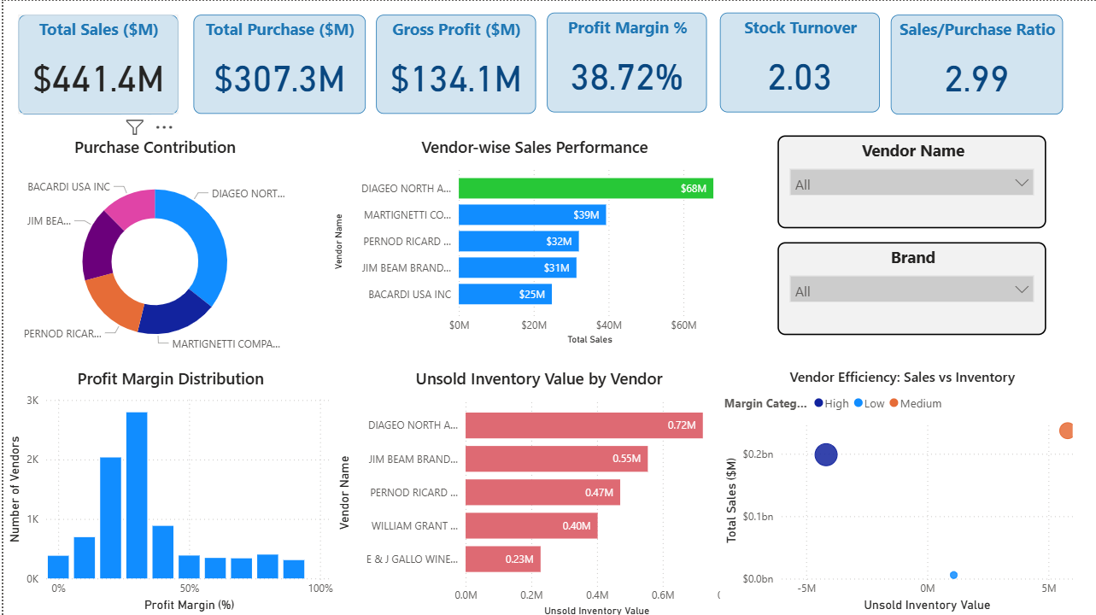

Project Overview:
This project focuses on analyzing vendor performance using sales, profitability, and inventory data. The objective was to identify high-performing vendors, detect inventory inefficiencies, and provide actionable insights for better procurement and inventory management decisions.
The dashboard enables stakeholders to monitor key financial and operational metrics, including total sales, gross profit, stock turnover, and unsold inventory value.

Business Objectives:
- Identify top-performing vendors based on sales and profitability
- Detect vendors with high unsold inventory (capital blockage)
- Analyze profit margin distribution across vendors
- Evaluate vendor efficiency using sales vs inventory relationship
- Support data-driven procurement and inventory decisions

Data Description:
The dataset contains vendor-level transactional and aggregated information including:
- Total Sales Dollars
- Total Purchase Dollars
- Gross Profit
- Profit Margin
- Stock Turnover
- Unsold Inventory Value
- Vendor Name and Brand
Derived metrics such as profit margin, sales-to-purchase ratio, and vendor contribution percentages were calculated using DAX measures.

Key Metrics (DAX Logic):
- Total Sales = SUM(TotalSalesDollars)
- Total Purchase = SUM(TotalPurchaseDollars)
- Gross Profit = SUM(GrossProfit)
- Profit Margin % = Gross Profit / Total Sales
- Unsold Inventory Value = (Purchase Quantity - Sales Quantity) × Purchase Price
- Stock Turnover = Average of stock turnover values

Key Insights:
- A small number of vendors contribute a significant portion of total sales. Top 6 vendors contribute nearly 50% of total sales.
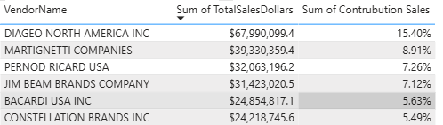
- High unsold inventory is concentrated among a few vendors . Nearly 80% of unsold inventory is concentrated in top 6 vendors.
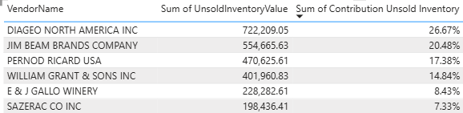
- Majority of vendors operate within a moderate profit margin range (10–30%).
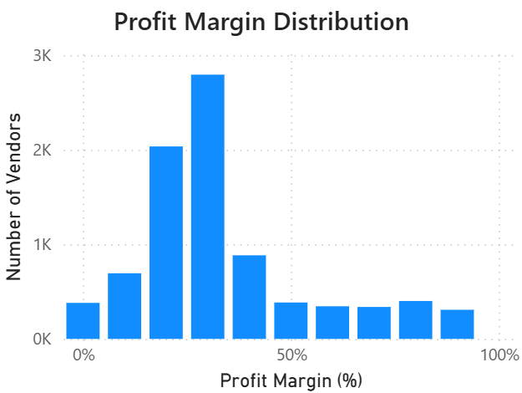
- Some vendors show high inventory but relatively low sales
- High-performing vendors demonstrate strong sales with controlled inventory

Business Impact:
- Identifies inefficient vendors and inventory bottlenecks
- Helps optimize procurement strategies
- Reduces working capital locked in unsold inventory
- Improves vendor selection and performance monitoring

